**Worksheet – 3.1**

**Student Name:** Vivek Kumar  **UID:** 21BCS8129

**Branch:** BE-CSE (LEET) **Section/Group:** 809/A

**Semester:** 4th **Date of Performance:** 20/04/2022

**Subject Name:** Programming in Python Lab  **Subject Code:** 20CSP-259

**1. Aim/Overview of the practical:**

1. Python program to implement linear search.
2. Python program to implement bubble sort.
3. Python program to implement binary search without recursion.
4. Python program to implement selection sort.

**2. Task to be done/ Which logistics used:**

1. Write a Python program to implement linear search.
2. Write a Python program to implement bubble sort.
3. Write a Python program to implement binary search without recursion.
4. Write a Python program to implement selection sort.

**3. Steps for experiment/practical/Code:**

1. Write a Python program to implement linear search.

**Source Code:**

def linear_Search(list1, n, key):

for i in range(0, n):

if (list1[i] == key):

return i

return -1

list1 = []

n = int(input('Enter the Size of the List: '))

for i in range(0,n):

ele=int(input())

list1.append(ele)

key = int(input('Enter the Key to be Searched: '))

res = linear_Search(list1, n, key)

if(res == -1):

print("Element {} not found in the list".format(key))

else:

print("Element {} found at index position {}: ".format(key,res))

1. Write a Python program to implement bubble sort.

**Source Code:**

def bubble_sort(list1,n):

for i in range(0,n-1):

for j in range(n-1):

if(list1[j]>list1[j+1]):

temp = list1[j]

list1[j] = list1[j+1]

list1[j+1] = temp

return list1

list1 = []

n = int(input('Enter the Size of the List: '))

for i in range(0, n):

ele = int(input())

list1.append(ele)

print("The Given Unsorted list is: ", list1)

print("The Sorted list is: ", bubble_sort(list1,n))

1. Write a Python program to implement binary search without recursion.

**Source Code:**

def binary_search(list1, key):

low = 0

high = len(list1) - 1

mid = 0

while low <= high:

mid = (high + low) // 2

if list1[mid] < key:

low = mid + 1

elif list1[mid] > key:

high = mid - 1

else:

return mid

return -1

list1 = []

n = int(input('Enter the Size of the List: '))

for i in range(0, n):

ele = int(input())

list1.append(ele)

key = int(input('Enter the Key to be Searched: '))

res = binary_search(list1, key)

if(res == -1):

print("Element {} not found in the list".format(key))

else:

print("Element {} found at index position {}: ".format(key, res))

1. Write a Python program to implement selection sort.

**Source Code:**

def selectionSort(array):

n = len(array)

for i in range(n):

minimum = i

for j in range(i+1, n):

if (array[j] < array[minimum]):

minimum = j

temp = array[i]

array[i] = array[minimum]

array[minimum] = temp

return array

list1 = []

n = int(input('Enter the Size of the List: '))

for i in range(0, n):

ele = int(input())

list1.append(ele)

print("The Given Unsorted list is: ", list1)

print("The Sorted list is: ", selectionSort(list1))

**4. Result/Output/Writing Summary:**

1. Write a Python program to implement linear search.

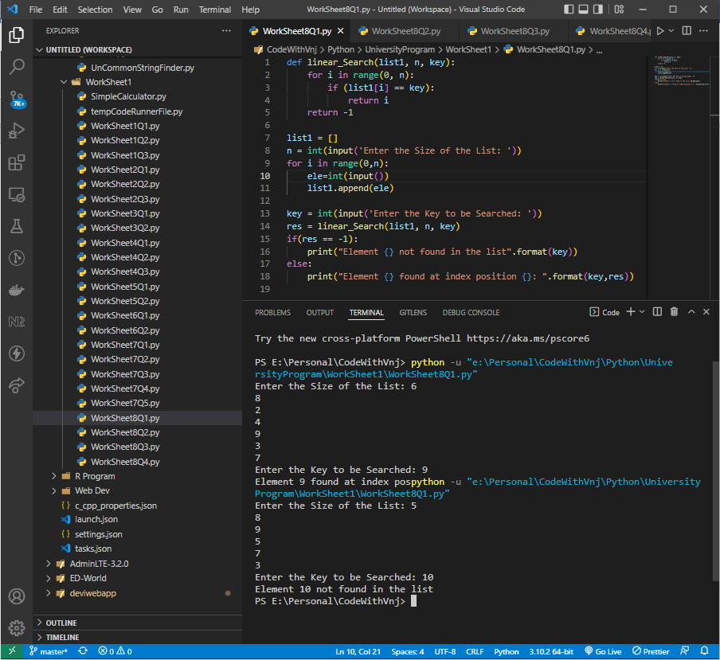

1. Write a Python program to implement bubble sort.

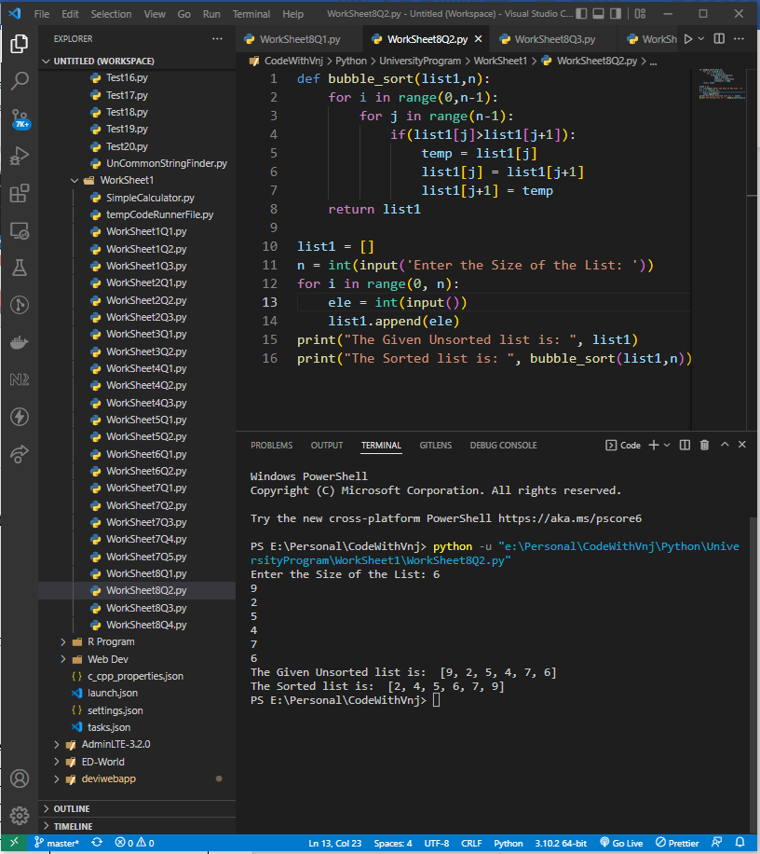

1. Write a Python program to implement binary search without recursion.

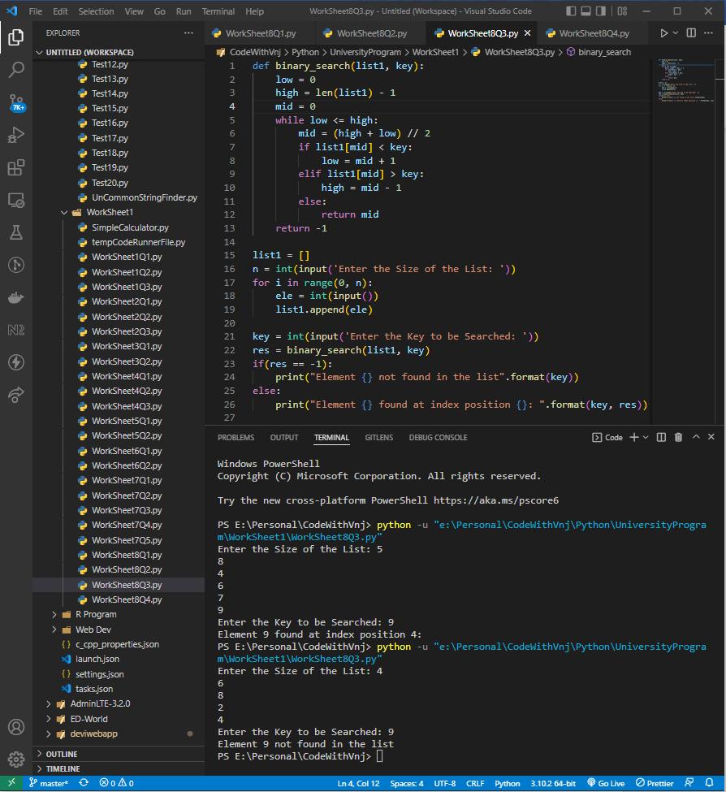

1. Write a Python program to implement selection sort**.**

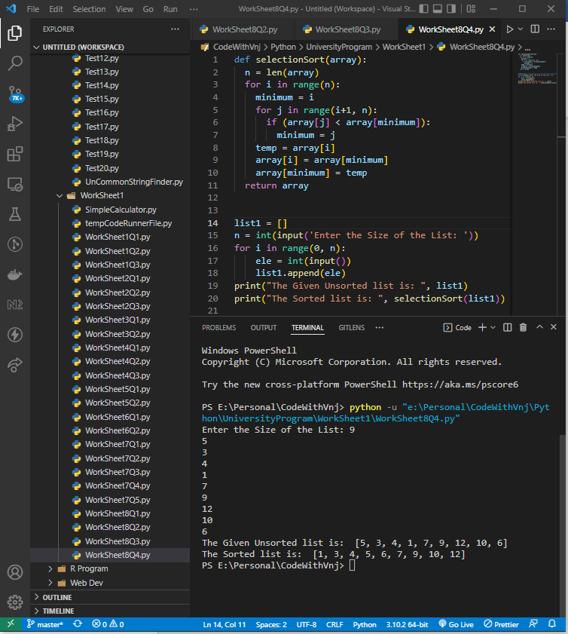

**Learning outcomes (What I have learnt):**

**1.** I have learnt, how to take List Input from User.

**2.** Learnt to implement various searching technique in the list.

**3.** Learnt to implement various sorting technique in the list.

**Evaluation Grid (To be created as per the SOP and Assessment guidelines by the faculty):**

|  |  |  |  |
| --- | --- | --- | --- |
| Sr. No. | Parameters | Marks Obtained | Maximum Marks |
| 1. |  |  |  |
| 2. |  |  |  |
| 3. |  |  |  |
| 4. |  |  |  |